
ADAMA SCIENCE AND TECHNOLOGY UNIVERSITY
COLLEGE OF ELECTRICAL ENGINEERING AND COMPUTING
INTEGRATED ENGINEERING TEAM PROJECT

IOT-BASED AUTOMATED ELECTRICAL VEHICLE CHARGING AND SMART PARKING MANAGEMENT SYSTEM

ASTU, ADAMA
MAY, 2026

APPROVAL
This is to certify that the project report entitled "IoT-Based Automated Electrical Vehicle Charging and Smart Parking Management System" submitted by the following students in partial fulfillment of the requirements for their respective Bachelor of Science degrees in Computer Science and Engineering (CSE), Software Engineering (SE), and Electrical Power and Control Engineering (EPCE), is a record of original work carried out by them under our supervision and guidance.
The project has been examined and approved as meeting the required academic standards.
Group Members:
- Mohammed Ismail UGR/30954/15 SE
- Abdurahman Elias UGR/30039/15 SE
- Salahadin Nuredin Husen UGR/31168/15 SE
- Hussein Beshir UGR/30697/15 SE
- Khalid Tewfik Abdela UGR/25508/14 EPCE
- Abduerhman Mohammed UGR/25422/14 EPCE
- Mohammed Sadik Nuri UGR/30960/15 CSE
- Betelhem Yehuala Abebe UGR/30284/15 CSE
- Efrata Wendwesen Eshetu UGR/30440/15 CSE
Approved by:
IETP Project Advisor:
Name: Mr. Raji Abebe (MSc.) Signature: _________________ Date: _______________
Department Chair:
Name: ___________________________Signature: ______________ Date: _______________

DECLARATION
We, the undersigned, hereby declare that this project is my original work and has not been presented for a degree in any other university, and all sources of materials used for this thesis have been duly acknowledged.
Group Members:
Name ID Dept. Sign
- Mohammed Ismail UGR/30954/15 SE __________
- Abdurahman Elias UGR/30039/15 SE __________
- Salahadin Nuredin Husen UGR/31168/15 SE __________
- Hussein Beshir UGR/30697/15 SE __________
- Khalid Tewfik Abdela UGR/25508/14 EPCE __________
- Abduerhman Mohammed UGR/25422/14 EPCE __________
- Mohammed Sadik Nuri UGR/30960/15 CSE __________
- Betelhem Yehuala Abebe UGR/30284/15 CSE __________
- Efrata Wendwesen Eshetu UGR/30440/15 CSE __________

This BSc project has been submitted for examination with my approval as thesis advisor.
Name: Mr. Raji Abebe (MSc.)
Signature: _________________________
Date of submission: ______________________

ACKNOWLEDGEMENT
We would like to express our deepest gratitude to our project advisor for their continuous guidance, technical insight, and invaluable support throughout the research and development of this simulation. Their mentorship was instrumental in helping us navigate the complex integration of hardware logic and software backend systems, ensuring our theoretical concepts translated into a functional virtual model.
We also extend our sincere appreciation to the faculties of the Computer Science and Engineering (CSE), Software Engineering (SE), and Electrical Power and Control Engineering (EPCE) departments. Their combined instruction provided the foundational knowledge and interdisciplinary framework necessary to execute a project of this complexity. The specialized coursework in embedded systems, database management, and power distribution was crucial in bridging the gap between our respective fields and allowing us to design a cohesive, multi-tiered architecture.
Furthermore, we wish to thank our colleagues across all three departments for their collaborative spirit and constructive feedback during the simulation testing phases. Their willingness to troubleshoot communication protocols and review system logic significantly improved the reliability and latency of our final design.
Finally, we owe a special debt of gratitude to our families for their unwavering encouragement, patience, and support throughout our academic journeys and the duration of this project. Their belief in our potential has been a constant source of motivation during the most demanding phases of our studies.

EXECUTIVE SUMMARY
This project details the design and simulation of an automated IoT-Based Smart Parking and Electric Vehicle Charging Station. Developed with the collaboration between of Computer Science, Software Engineering, and Electrical Power and Control Engineering students, the project addresses urban challenges of inefficient parking management and decentralized EV charging. The objective was to engineer a seamless system managing automated entry, power metering, and digital billing.
Because the project emphasizes logic over physical prototyping, the hardware was entirely simulated in Proteus 8 Professional. The architecture uses a simulated Arduino Mega 2560 connected to virtual ultrasonic sensors, current sensors, relays, and virtual terminals (acting as RFID and License Plate scanners).
To connect the isolated simulation to web platforms, the team used the COM Port Physical Interface Model (COMPIM) and Node-RED middleware. This allowed real-time serial communication between the hardware and a central database, supporting an administrator dashboard and a customer web application for remote monitoring. Concurrently, the system calculates EV energy consumption based on a 220V grid and a simulated 32A load.
The simulation demonstrated a highly responsive, low-latency system. The workflow successfully executed gate actuation upon credential verification, accurate power tracking during charging, and exit processing following mobile payment confirmation. This virtual proof-of-concept validates the proposed IoT architecture, providing a robust blueprint for future physical prototyping and urban deployment.

Contents
APPROVAL i
DECLARATION ii
ACKNOWLEDGEMENT iii
EXECUTIVE SUMMARY iv
TABLE OF FIGURES vii
LIST OF TABLES vii
LIST OF ACRONYMS viii
CHAPTER ONE 1
INTRODUCTION 1
1.1 BACKGROUND OF THE STUDY 1
1.2 STATEMENT OF THE PROBLEM 1
1.3 OBJECTIVES OF THE STUDY 2
1.3.1 GENERAL OBJECTIVE 2
1.3.2 SPECIFIC OBJECTIVES 2
1.4 SIGNIFICANCE OF THE STUDY 2
1.5 SCOPE AND LIMITATIONS 3
CHAPTER TWO 4
LITERATURE REVIEW 4
2.1 OVERVIEW 4
2.2 EXISTING TECHNOLOGIES AND SOLUTIONS 4
2.3 IDENTIFIED RESEARCH GAPS 5
2.4 THEORETICAL FRAMEWORK 5
CHAPTER THREE 7
SOFTWARE DEVELOPMENT 7
3.1 OVERVIEW 7
3.2 HIGH-LEVEL SYSTEM ARCHITECTURE 7
3.3 DATABASE DESIGN AND MANAGEMENT 7
3.4 MIDDLEWARE DEVELOPMENT (NODE-RED) 8
3.5 USER INTERFACE (UI) AND BILLING INTEGRATION 8
3.5.1 ADMINISTRATOR WEB DASHBOARD 8
3.5.2 EV DRIVER MOBILE INTERFACE 8
CHAPTER FOUR 10
SYSTEM DESIGN 10
4.1 HARDWARE ARCHITECTURE 10
4.2 COMMUNICATION PROTOCOLS 10
4.3 POWER & CONTROL LOGIC 11
4.4 SYSTEM DATA FLOW 11
CHAPTER FIVE 14
SIMULATION AND INTEGRATION 14
5.1 OVERVIEW 14
5.2 HARDWARE SIMULATION ENVIRONMENT 14
5.2.1 SENSOR AND ACTUATOR LAYOUT 16
5.2.2 VIRTUAL TERMINALS FOR CREDENTIAL SIMULATION 16
5.3 MIDDLEWARE AND NETWORK INTEGRATION 17
5.3.1 COMPIM CONFIGURATION 17
5.3.2 NODE-RED WORKFLOW 17
5.4 EV CHARGING POWER SIMULATION 18
5.5 USER INTERFACE AND BILLING INTEGRATION 19
CHAPTER SIX 22
CONCLUSION AND RECOMMENDATION 22
6.1 CONCLUSION 22
6.2 RECOMMENDATION 23
REFERENCES 25
APPENDICES 26
APPENDIX A: ARDUINO MICROCONTROLLER SOURCE CODE 26

TABLE OF FIGURES
Figure 2.1: Three-Layer IoT Architecture 6
Figure 4.2: System Operational Flowchart 11
Figure 5.1 Complete Proteus Schematic of the system 14
Figure 5.2: COMPIM Module Configuration 15
Figure 5.3: Node-RED Event-Driven Workflow for Hardware-to-Cloud Integration. 16
Figure 5.4: Simulated High-Voltage Relay Circuit for EV Power Delivery 16

LIST OF TABLES
Table 5.1: Simulated Hardware Components 12
Table 5.2: Test cases of the system 17

LIST OF ACRONYMS
ALPR Automated License Plate Recognition
COMPIM COM Port Physical Interface Model
CSE Computer Science and Engineering
EPCE Electrical Power and Control Engineering
EV Electric Vehicle
IDE Integrated Development Environment
IoT Internet of Things
LPR License Plate Recognition
RFID Radio Frequency Identification
SE Software Engineering

CHAPTER ONE

INTRODUCTION

1.1 BACKGROUND OF THE STUDY
The rapid global transition toward electric vehicles (EVs) is a cornerstone of sustainable transportation and carbon emission reduction. However, the concurrent rise in EV adoption has exposed critical infrastructure gaps, particularly in urban parking and charging ecosystems. Drivers frequently face two interrelated challenges: finding an available parking space and locating a functional, accessible EV charging station. Traditional parking management systems rely on manual monitoring or simple entry-exit counters, neither of which provides real-time occupancy data or predictive availability. Similarly, most EV charging stations operate independently without communicating parking status or reservation capabilities. This disconnect means that a driver cannot reliably know, before arriving, whether both a parking spot and a functioning charger will be available.
The Internet of Things (IoT) offers a transformative solution by enabling sensors, networked devices, and cloud platforms to communicate continuously. This project proposes the design and implementation of an IoT-based automated electric vehicle charging and smart parking management system that integrates real-time occupancy monitoring, intelligent charger allocation, remote reservation, and unified automated billing. The successful deployment of this system is expected to reduce average parking search time by up to 40%, decrease unnecessary driving, and improve EV charger turnover rates, ultimately providing a scalable, cost-effective blueprint for smart city infrastructure in Addis Ababa, Ethiopia.

1.2 STATEMENT OF THE PROBLEM
Existing electric vehicle (EV) charging and parking management systems suffer from five critical problems: lack of real-time parking and charger availability information, no integration between parking management and charging systems, inefficient charger utilization and long idle times, no reservation or guidance system for EV drivers, and manual, inefficient billing and payment processes. Drivers cannot reliably know before departure whether both a parking space and a functioning charger are available, as parking and charging systems operate separately without communication. This forces physical searching, wasting time and battery range while increasing congestion. EV chargers are frequently occupied by fully charged vehicles with no mechanism to notify drivers or impose idle fees, reducing charger throughput and increasing wait times. Additionally, current systems do not allow advance reservation of combined parking and charging spots, contributing to range anxiety. Finally, fragmented payment methods create billing errors, payment delays, poor user experience, and revenue leakage for facility operators

1.3 OBJECTIVES OF THE STUDY

1.3.1 GENERAL OBJECTIVE
The general objective of this study is to design, develop, and validate an IoT-based automated electric vehicle (EV) charging and smart parking management system. This system will integrate real-time occupancy monitoring, intelligent charger allocation, remote reservation, and unified automated billing to eliminate information gaps, reduce driver wait times, and optimize infrastructure utilization in modern urban parking facilities.

1.3.2 SPECIFIC OBJECTIVES
To achieve the general objective, the following specific objectives have been established:
- Design and implement a cohesive sensor network for the real-time detection of parking space occupancy and EV charger status, coupled with a cloud-based dashboard and mobile interface to broadcast unified availability data to drivers prior to arrival.
- Develop a centralized software platform to consolidate telemetry from both parking sensors and EV charging units into a single database, facilitating cross-functional analytics and providing facility operators with unified, comprehensive system control.
- Deploy an automated monitoring and notification protocol capable of tracking charging session durations, detecting charge completion, alerting drivers for required vehicle relocation, and autonomously applying idle fees following a configurable grace period.

1.4 SIGNIFICANCE OF THE STUDY
This study holds significant theoretical, methodological, practical, and societal value. Theoretically, it extends existing literature on IoT-enabled smart parking by introducing an integrated model that combines parking occupancy detection with EV charger status monitoring, filling a geographic gap in smart city research through empirical data collected in Addis Ababa, Ethiopia. Methodologically, it demonstrates a mixed-methods approach combining quantitative system data with qualitative user feedback, validates a controlled experiment design for comparing camera-based IoT systems against conventional parking operations, and develops a data collection instrument that can be replicated in other multilingual contexts. Practically, the proposed system will reduce driver search time for parking and charging, lower traffic congestion, enable automated billing and idle fee enforcement, and provide facility operators with real-time occupancy analytics. The beneficiaries include EV drivers in Addis Ababa who will experience reduced range anxiety and improved convenience, parking facility operators who will gain automated revenue collection and usage analytics, government and traffic authorities who will receive data-driven insights for EV adoption policy, Ethio Telecom and payment providers who can integrate telebirr payments, researchers who will access empirical data from an African urban context, the general public who will benefit from reduced congestion and improved air quality.

1.5 SCOPE AND LIMITATIONS
Data will be collected from two sources: traffic movement patterns and end-user inputs, using camera-based computer vision for real-time detection of parking occupancy, vehicle types, and charger status, alongside user interactions from a mobile application for easy access. The temporal scope covers six months of data collection, including historical traffic data from Ethiopian authorities, real-time pilot facility data, and continuous user feedback to capture daily, weekly, and seasonal variations. The analytical scope employs sentiment analysis, thematic content analysis, and statistical analysis (descriptive, comparative, and correlation), including a controlled experiment against conventional parking operations. The study is methodologically delimited to a mixed-methods approach using only camera-based computer vision for occupancy detection, beginning with four pilot facilities but designed for scalability. The following are excluded: wireless inductive charging technology, vehicle-to-grid (V2G) power transfer, autonomous vehicle support, custom hardware manufacturing, long-term maintenance evaluation beyond six months, and non-EV parking management.

CHAPTER TWO

LITERATURE REVIEW

2.1 OVERVIEW
This section reviews existing literature, technologies, and solutions relevant to IoT-based smart parking and EV charging management systems. The review examines global and Ethiopian contexts, focusing on five key areas: AI and computer vision for smart parking, IoT in smart EV charging management, wireless EV charging integrated with smart parking, intelligent monitoring systems for EV charging stations, and the digitalization of smart parking systems. The purpose of this review is to identify current technological capabilities, understand existing challenges, recognize research gaps, and position the current study within the broader body of knowledge. By critically evaluating previous work, this section establishes the foundation for the proposed system and justifies the need for an integrated IoT-based solution tailored to Ethiopian urban conditions.

2.2 EXISTING TECHNOLOGIES AND SOLUTIONS
Existing smart parking solutions primarily fall into three categories: sensor-based systems using ultrasonic or inductive sensors for occupancy detection, vision-based systems using cameras and AI algorithms such as YOLOv8 and Mask R-CNN for vehicle identification, and hybrid systems combining multiple technologies. For EV charging management, current solutions include IoT-enabled charging stations with real-time monitoring capabilities, predictive maintenance systems (e.g., Tesla's system), smart charging platforms (e.g., Enel X's JuiceNet), and vehicle-to-grid (V2G) integration. However, these technologies operate largely in isolation, parking systems do not communicate with charging systems, and there is no unified platform that provides drivers with combined real-time information on both parking availability and charger status. In Ethiopia, recent initiatives include Ethio Telecom's AI-driven EV charging network with telebirr payment integration and Aries Investment's automated parking project, but these remain focused on either charging or parking separately, with no integrated solution validated under Ethiopian urban conditions.

2.3 IDENTIFIED RESEARCH GAPS
Based on the review of existing literature and technologies, the following five research gaps have been identified:
- No integrated system that combines real-time parking occupancy and EV charger status into a single platform.
- No empirical validation of IoT-based occupancy detection under Ethiopian urban conditions (dust, power variability, mixed vehicle types).
- No idle time management system tested with actual Ethiopian EV driver behavior and preferences.
- No comparative platform analysis (sensors, communication protocols, cloud architecture) optimized for Ethiopian infrastructure constraints.
- No empirical temporal pattern analysis (daily, weekly, seasonal) of parking and charging demand specific to Ethiopian cities.

2.4 THEORETICAL FRAMEWORK
The following five theories form the theoretical foundation of this study:
- Technology Acceptance Model (TAM): This theory explains how users come to accept and use new technology. It suggests that perceived usefulness and perceived ease of use determine behavioral intention to use a system. This study applies TAM to understand EV drivers' acceptance of the proposed IoT-based parking and charging system.
- Theory of Planned Behavior (TPB): This theory links beliefs and behavior, suggesting that behavioral intention is influenced by attitude, subjective norms, and perceived behavioral control. It guides the study's analysis of driver willingness to adopt reservation systems, idle fees, and automated billing.
- Diffusion of Innovation Theory (DOI): This theory explains how, why, and at what rate new technologies spread through cultures. It helps position the proposed system within Ethiopia's current EV adoption stage and identifies factors that may accelerate or hinder diffusion.
- IoT Architecture Framework (Three-Layer Model): This framework structures IoT systems into three layers: perception layer (sensors and cameras), network layer (communication protocols), and application layer (cloud platforms and user interfaces). It provides the architectural blueprint for system design and integration.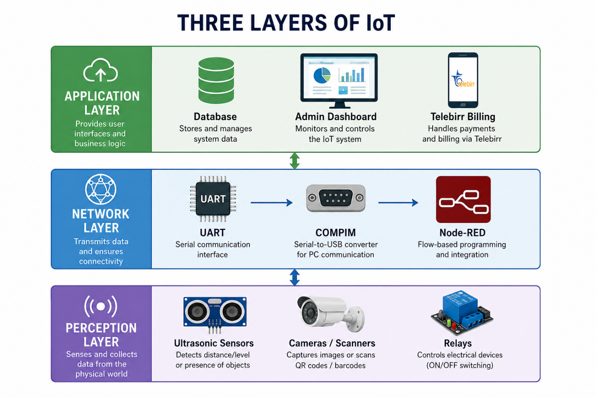
1Figure 2.1: Three-Layer IoT Architecture

CHAPTER THREE

SOFTWARE DEVELOPMENT

3.1 OVERVIEW
This chapter outlines the software architecture and development phases of the IoT-Based Smart Parking and EV Charging System. While Chapter Four details the local hardware logic, this chapter focuses on the higher-level software layers that enable remote monitoring, user authentication, and digital billing. The software stack is divided into three primary components: the centralized database, the middleware for event-driven logic (Node-RED), and the User Interface (UI) for both administrators and EV drivers.

3.2 HIGH-LEVEL SYSTEM ARCHITECTURE
The software architecture follows a client-server-edge model designed for low latency and high reliability. The "edge" consists of the local Arduino microcontroller managing the physical sensors and relays. The "server" layer is handled by Node-RED, which acts as the MQTT/Serial broker and logic engine. The "client" layer represents the web dashboards and mobile applications accessed by the end-users.

3.3 DATABASE DESIGN AND MANAGEMENT
To facilitate real-time user verification and automated billing, a relational database model was designed. The database is accessed and queried continuously by the Node-RED middleware whenever a vehicle arrives at the entry gate or initiates a charging session.
The database schema consists of three primary tables:
- Users Table: Stores driver credentials, including a unique User_ID (linked to the RFID card), Name, Phone_Number, and Wallet_Balance (for digital payment integration).
- Vehicles Table: Links the License_Plate to a specific User_ID to support the Automated License Plate Recognition (ALPR) system.
- Sessions Table: The most critical table for the billing system. It records the Session_ID, Entry_Time, Exit_Time, Bay_Number, Energy_Consumed_kWh, and the Total_Calculated_Fee.

3.4 MIDDLEWARE DEVELOPMENT (NODE-RED)
Node-RED was selected as the middleware platform due to its highly efficient, event-driven, flow-based programming model built on Node.js. It serves as the vital bridge between the local serial data coming from the Arduino and the external web services.
The software logic developed in Node-RED performs the following automated tasks:
- Data Parsing: It continuously listens to the COM port. When a raw string like ID:12345 is received, a JavaScript function node parses the string and extracts the ID.
- Authentication Routing: The parsed ID is cross-referenced with the database. If a match is found, Node-RED sends a GATE: OPEN payload back to the hardware.
- Energy and Time Calculation: Node-RED initializes virtual timers the moment a charging relay is activated. Upon disconnection, it computes the total energy using the formula E=P * t and pushes this variable to the billing node.

3.5 USER INTERFACE (UI) AND BILLING INTEGRATION
The application layer was developed to provide intuitive control and monitoring for two distinct user groups:

3.5.1 ADMINISTRATOR WEB DASHBOARD
Built using Node-RED Dashboard nodes, the administrator UI provides facility managers with a real-time overview of the parking lot. The interface features graphical gauges displaying current grid power consumption (in kW), binary color indicators (Green/Red) for parking bay occupancy, and a live terminal log showing vehicle entry and exit timestamps.

3.5.2 EV DRIVER MOBILE INTERFACE
To simulate the end-user experience, a mobile-responsive web interface was designed for the EV drivers. This UI allows drivers to remotely check parking bay availability before arriving at the station, mitigating range anxiety.
Furthermore, the interface houses the digital checkout system. Upon exiting the facility, the software aggregates the parking duration fee and the EV charging fee. To ensure regional viability within Ethiopia, the UI logic is designed to trigger a digital payment API prompt, simulating an integration with Ethio Telecom’s Telebirr platform. Only upon receiving a digital payment confirmation does the software authorize the exit gate to open.

3.6 FRONTEND WEB APPLICATION

3.6.1 Frontend Architecture and Tech Stack
The frontend of the integrated platform is implemented as a Next.js 16 web application built with React 19 and TypeScript. It uses the App Router for file-system routing, React Server Components for data fetching, Tailwind CSS v4 for styling, and a shadcn/ui component library layered on top of Base UI primitives. The icon set is provided by lucide-react. The codebase is organized around role-based route groups so that each user category is served a tailored interface from a shared design system.
The top-level layout under app/(dashboard) wraps three distinct experiences — administrator, supervisor, and end-user — behind a unified shell that includes a role-aware sidebar, header, and notification panel. Authentication state, role information, and refresh tokens are managed via HTTP-only cookies issued by the backend, which the Next.js middleware reads to enforce route-level access control. The development workflow uses next dev against the locally running Express API and PostgreSQL container.

3.6.2 Administrator Dashboard
Once an administrator authenticates, the platform routes them to the admin landing page under app/(dashboard)/admin. This top-level dashboard consolidates global system health, station performance, charging-session activity, and financial summaries in a single view. It surfaces real-time counters for active sessions, available bays, and active charging power, alongside historical revenue and utilization trends. From the same shell the administrator can navigate to the management module (users, vehicles, stations, slots, assignments), the finances module (invoices, transactions), the audit-log module, and the system settings module — each backed by a dedicated set of REST endpoints on the Express backend.
[INSERT IMAGE HERE — Administrator Dashboard]
Figure 3.1: Administrator Dashboard

3.6.3 Supervisor Management Interface
Supervisors operate a constrained subset of the admin experience scoped to day-to-day station operations. The supervisor module under app/(dashboard)/supervisor/management provides an operational console for monitoring slot occupancy, creating and closing slot assignments, registering vehicles, and resolving session issues. Supervisors can issue charging-session adjustments, flag faulty slots, and review audit logs filtered to their region. The interface deliberately omits user-management and system-settings actions, which remain administrator-only; backend authorization is enforced both at the route guard layer in the Next.js shell and at the role middleware on the Express API.
[INSERT IMAGE HERE — Supervisor Management]
Figure 3.2: Supervisor Management Interface

3.6.4 End-User (Driver) Dashboard
The end-user dashboard under app/(dashboard)/user is designed for drivers who have registered vehicles with the system. After login, the driver lands on a personalized overview that displays their active or most recent charging session, current wallet balance, and outstanding invoices. The finances sub-page exposes a full history of invoices, wallet top-ups, and per-session billing breakdowns — energy delivered in kWh, idle minutes, facility fees, taxes, and grand total. Drivers can manage saved payment methods, top up their wallet, pay open invoices, and download PDF receipts. The experience is intentionally minimal: the data model already enforces the linkage between assignments, transactions, and invoices, so the dashboard only needs to present the user-scoped projection returned by the /my-* family of endpoints.
[INSERT IMAGE HERE — End-User Dashboard]
Figure 3.3: End-User (Driver) Dashboard

3.7 BACKEND API SERVER

3.7.1 Backend Architecture and Tech Stack
The backend is implemented as a Node.js 20+ service written in TypeScript (ESM) and served by Express 5. It exposes a versioned REST API at /api/v1 and is composed of a thin route layer that delegates to a service layer, which in turn talks to PostgreSQL through Prisma ORM. The application bootstrap (server/src/app.ts) hardens HTTP responses with Helmet, enables CORS with credentials for the configured frontend origins, parses JSON and cookies, and installs structured request logging via pino-http. A typed environment loader validates all required variables on startup, and a centralized error handler converts thrown service errors into consistent JSON responses with appropriate HTTP status codes.

3.7.2 Authentication, Authorization, and Sessions
User authentication is implemented with bcrypt password hashing and stateless JWT access tokens delivered alongside opaque refresh tokens. Refresh tokens are persisted in the refresh_tokens table with a hashed value, an expiry, a revocation timestamp, and a replacedById field that records the rotation chain, enabling reuse detection. Tokens are issued and rotated through the /auth routes, stored as HTTP-only cookies by the client, and validated by a middleware that attaches the authenticated user (with role and region) to every downstream request. A role-guard middleware then enforces the ADMIN, SUPERVISOR, USER hierarchy at the route level. Password resets are handled through the password_reset_tokens table and a Nodemailer-based mailer.

3.7.3 RESTful Resource Modules
The API is organized into focused resource modules under server/src/routes: auth, users, vehicles, stations, slots, assignments, transactions, invoices, finances, my-finances, my-sessions, my-wallet, notifications, logs, dashboard, settings, search, me, and health. Each route file is paired with a service file in server/src/services that contains the business logic and Prisma queries, and most write endpoints validate their payloads against Zod schemas defined under server/src/schemas. The /dashboard endpoint aggregates the KPI rollups consumed by the administrator landing page; the /my-* endpoints provide the user-scoped projections consumed by the driver dashboard; and the /finances and /invoices endpoints render invoice PDFs on demand using pdfkit.

3.7.4 Data Model and Persistence Layer
PostgreSQL is the system of record, accessed through Prisma. The schema (server/prisma/schema.prisma) models the core domain entities — User, Station, Slot, Vehicle, SlotAssignment, Transaction, Invoice, InvoiceLineItem, AuditLog, Notification, SystemSettings, and SystemMetricsSnapshot — together with the USER-role financial entities Wallet, WalletTransaction, and UserPaymentMethod. The SlotAssignment model is the operational heart of the system: it links a Vehicle to a Slot, captures arrival and departure timestamps, and (for CHARGE_AND_PARK slots) records the EV-session metering produced by the simulated Arduino layer — energy delivered in kWh, peak and current power in kW, state of charge, estimated remaining minutes, connector type, and carbon-offset estimate — alongside the full cost breakdown (energy cost, facility fee, idle fee, tax, grand total). A partial unique index named one_active_per_slot is created in a raw migration to guarantee that no slot can hold two simultaneous ACTIVE assignments.

3.7.5 Security, Observability, and Local Operations
In addition to Helmet and CORS, the API uses express-rate-limit to throttle sensitive endpoints (login, password reset, token refresh) and writes every privileged action to the audit_logs table via a dedicated audit service. All HTTP traffic is logged in structured JSON through pino-http, and a /health endpoint provides a liveness signal that is excluded from log noise. For local development the repository ships a docker-compose.yml that provisions PostgreSQL, allowing the team to run pnpm prisma migrate dev, pnpm prisma:seed, and pnpm dev to bring up a fully integrated stack against which the Next.js client and the Proteus plus Node-RED simulation layer can be exercised end-to-end.

CHAPTER FOUR

SYSTEM DESIGN

4.1 HARDWARE ARCHITECTURE
Because this project emphasizes software-hardware integration without a physical prototype, the entire hardware architecture is virtually constructed and simulated using Proteus 8 Professional. The central processing unit governing the local hardware logic is an Arduino Mega 2560. This microcontroller was selected due to its extensive I/O pin count and multiple hardware serial ports, which are critical for interfacing with various simulated subsystems simultaneously.
The simulated components integrated with the Arduino Mega 2560 include:
- Virtual Terminals: Acting as stand-ins for physical Radio Frequency Identification (RFID) card readers and Automated License Plate Recognition (ALPR) cameras. These terminals allow the engineering team to manually input alphanumeric strings to simulate scanned credentials.
- Ultrasonic Sensors: Positioned virtually at the parking bays to detect vehicle presence, changing state when a car occupies the spot.
- Current Sensors: Simulated analog input components that monitor the current draw during the electric vehicle (EV) charging phase.
- Relay Modules: Used to logically switch the high-voltage EV charging circuit on and off based on authorization from the main controller.
- Motor Actuators: Simulated Servo motors representing the physical entry and exit toll gates, configured to open and close upon receiving authorization signals.

4.2 COMMUNICATION PROTOCOLS
The primary communication protocol utilized within this hardware simulation is Serial Communication (UART). The Arduino Mega 2560 transmits and receives structured data strings such as sensor states, RFID tag IDs, and license plate strings over its serial ports. To bridge the gap between the isolated Proteus simulation and the external backend server (Node-RED), the system utilizes the COM Port Physical Interface Model (COMPIM). COMPIM maps the virtual serial pins of the simulated Arduino to the physical or virtual COM ports of the host computer, enabling real-time, bi-directional data exchange between the hardware layer and the software database.

4.3 POWER & CONTROL LOGIC
A core objective of the Electrical Power and Control Engineering (EPCE) team is to simulate the accurate distribution and measurement of power to the EV charger. The control logic relies on a designated relay connected to the main grid. When the system verifies that an authorized vehicle is parked and permitted to charge, the Arduino sends a HIGH signal to the relay, closing the circuit and allowing power to flow.
The charging station operates on a standard simulated AC grid voltage of V = 220V. The system assumes a constant measured current draw of I = 32A when the vehicle is actively charging.
The instantaneous power (P) drawn by the vehicle is calculated using the standard electrical power formula:
P = V * I
Substituting the known values:
P = 220V * 32A = 7040W = 7.04kW
The system tracks the total time (t, in hours) that the relay remains closed. The total energy consumed (E, in kilowatt-hours) is then calculated as:
E = P * t
This energy value is transmitted via serial communication to the database, allowing the administrative software to accurately log usage and calculate billing costs for the customer.

4.4 SYSTEM DATA FLOW
The operational data flow of the smart parking and charging station is highly automated, functioning in a strict sequence to ensure security and accurate billing:
- Arrival and Verification: A vehicle pulls up to the entry gate. The user's pre-made card is scanned, and the license plate is read (simulated by typing the IDs into the Proteus Virtual Terminal).
- Database Check: The Arduino sends the scanned data via serial (COMPIM) to Node-RED, which queries the central database to verify if the user and vehicle are registered.
- Entry Gate Actuation: Upon receiving a "Success" signal from the database, the Arduino triggers the entry motor driver. The gate opens, the car passes through, and the gate automatically closes behind it.
- Parking and Charging Authorization: The vehicle parks in an available EV charging bay. The ultrasonic sensor detects the car's presence. The system verifies if the parked user has authorized a charging session.
- Power Delivery: If authorized, the Arduino triggers the charging relay. Power (220V / 32A) is supplied to the vehicle, and the simulated current sensor begins tracking the active load and duration.
- Departure: Once charging is complete, the relay is deactivated. The vehicle pulls out of the bay and proceeds to the exit gate.
- Exit Scan and Payment: The user's card is scanned at the exit. The system calculates the final cost based on the power consumed (E = P * t) and the parking duration. The user processes the payment via a mobile phone application.
- Exit Gate Actuation: Once Node-RED confirms the digital payment is successful, an authorization string is sent back to the Arduino. The exit gate opens, allowing the car to leave the facility, and subsequently closes, resetting the cycle.
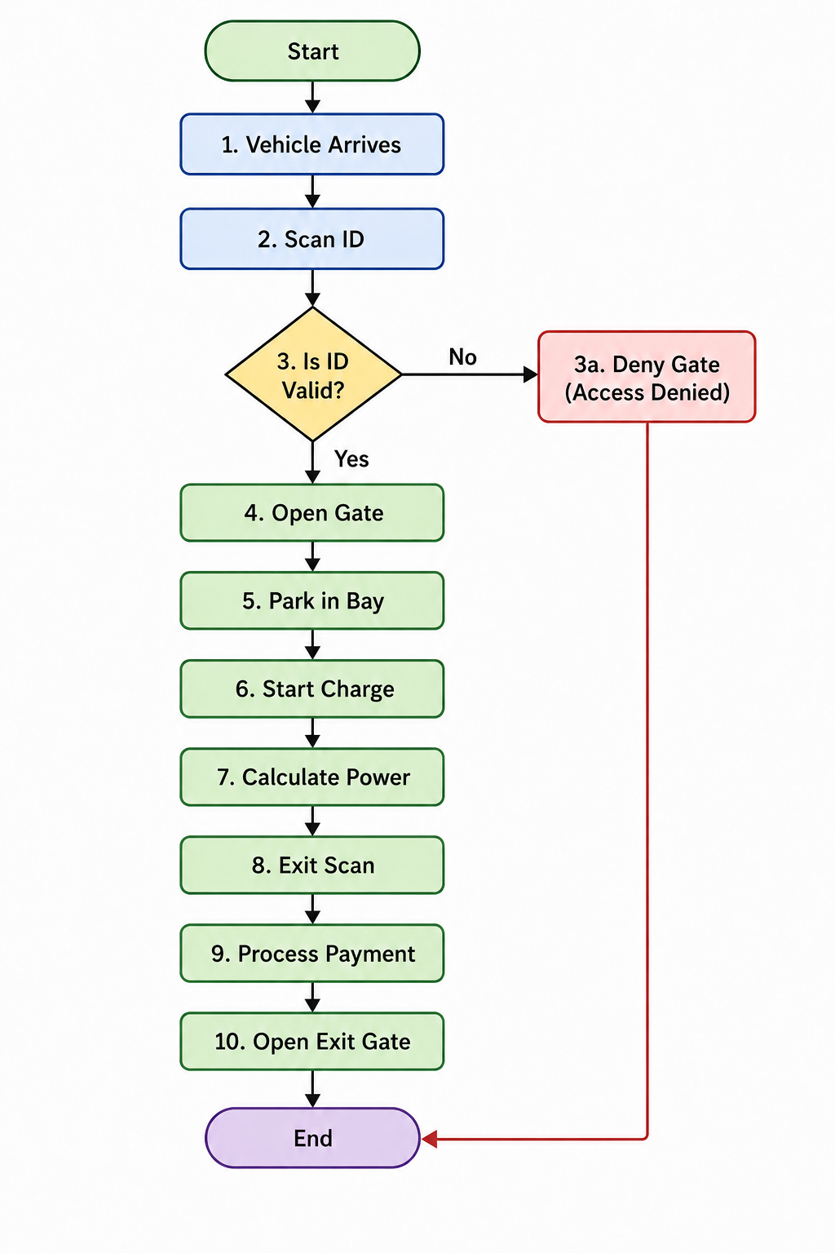
2Figure 4.2: System Operational Flowchart

CHAPTER FIVE

SIMULATION AND INTEGRATION

5.1 OVERVIEW
This chapter details the practical implementation of the system design through software simulation and middleware integration. Because this project emphasizes logical validation and software-hardware integration without a physical prototype, the entire environment is virtualized. The chapter covers the construction of the virtual hardware environment in Proteus 8 Professional, the integration of middleware via Node-RED, backend database connectivity, and the execution of real-time test scenarios to validate the proposed IoT architecture.

5.2 HARDWARE SIMULATION ENVIRONMENT
The hardware perception and control layers were fully modeled using Proteus 8 Professional. The simulation is centralized around the Arduino Mega 2560 microcontroller, chosen for its multiple UART ports necessary for handling parallel subsystems.
1Table 5.1: Simulated Hardware Components
Physical Component | Proteus Virtual Component | Purpose / System Function | Arduino Mega Connection
RFID Reader / ALPR Camera | Virtual Terminal | Acts as the serial input interface to manually type alphanumeric strings, simulating scanned vehicle plates or user ID cards. | TX1 / RX1 (Serial1)
Ultrasonic Sensor (HC-SR04) | Ultrasonic Sensor Model | Detects the physical presence of a vehicle in the parking and charging bays. | Digital Pins (Trig & Echo)
Entry & Exit Boom Gates | Servo Motor | Simulates the mechanical toll gates. Rotates 90 degrees to allow vehicle entry or exit upon authorization. | PWM Pins (e.g., Pin 9, Pin 10)
EV High-Voltage Switch | Relay Module (SPDT) | Acts as the logical switch to connect or disconnect the 220V grid power to the electric vehicle. | Digital Output Pin
Current/Energy Meter | Current Sensor & AC Alternator | Monitors the power draw. Simulates the local grid (220V) and constant EV charging load (32A). | Analog Input Pin (e.g., A0)
Local Driver Kiosk Screen | LM016L (16x2 LCD Display) | Provides local visual feedback to the driver (e.g., "Access Granted", "Charging Started", "Scan to Exit"). | I2C (SDA/SCL) or Digital Pins
IoT Wi-Fi/GSM Module | COMPIM Model | Bridges the isolated Proteus simulation to the external Node-RED server and database via virtual COM ports. | TX0 / RX0 (Serial0)

5.2.1 SENSOR AND ACTUATOR LAYOUT
Four parking bays are simulated, each equipped with an ultrasonic sensor to detect vehicle occupancy. LCD screens are wired to the microcontroller to provide local visual feedback (e.g., "Welcome," "Scan ID," "Charging..."). Servo motors act as the mechanical gates, parameterized to rotate 90 degrees upon receiving a HIGH logic signal.
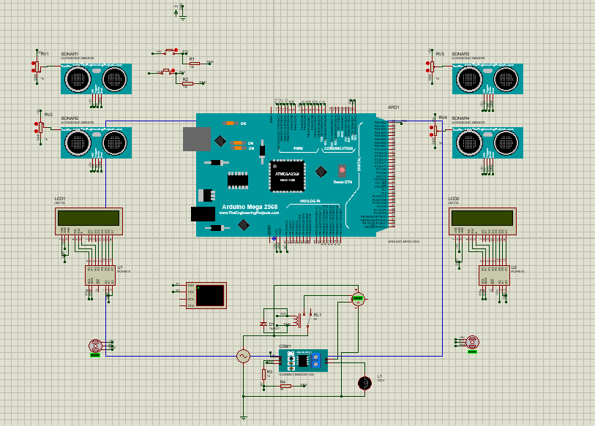
3Figure 5.1 Complete Proteus Schematic of the system

5.2.2 VIRTUAL TERMINALS FOR CREDENTIAL SIMULATION
To simulate the Automated License Plate Recognition (ALPR) cameras and RFID card readers, Proteus Virtual Terminals were utilized. During the simulation runtime, the engineering team inputs pre-registered alphanumeric strings into these terminals to mimic a vehicle pulling up and presenting its credentials.

5.3 MIDDLEWARE AND NETWORK INTEGRATION
A critical success factor of this project is proving that the isolated hardware simulation can communicate with a live cloud or local backend. This was achieved using the COM Port Physical Interface Model (COMPIM) in Proteus paired with Node-RED.

5.3.1 COMPIM CONFIGURATION
The COMPIM module maps the virtual TX/RX serial pins of the simulated Arduino Mega to the physical/virtual COM ports of the host PC running the simulation. This allows the Proteus environment to send and receive real-world serial data.
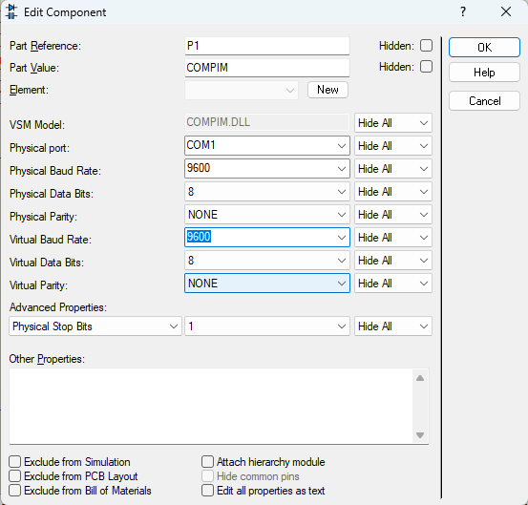
4Figure 5.2: COMPIM Module Configuration

5.3.2 NODE-RED WORKFLOW
Node-RED serves as the central middleware. It listens to the designated COM port for incoming data strings from the Proteus simulation (e.g., "ID:12345, BAY:2, STATUS: PARKED"). Node-RED parses this data, queries the database to verify user credentials, and sends commands back to Proteus (e.g., "GATE: OPEN" or "RELAY: ON").
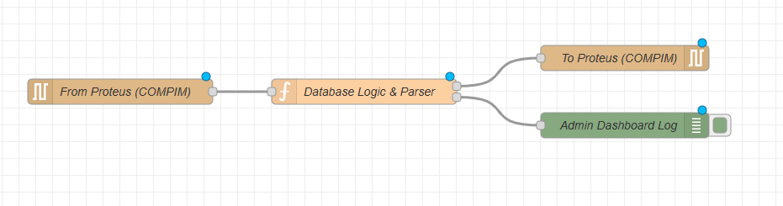
5Figure 5.3: Node-RED Event-Driven Workflow for Hardware-to-Cloud Integration.

5.4 EV CHARGING POWER SIMULATION
The Electrical Power and Control Engineering (EPCE) logic dictates the power delivery simulation. The virtual circuit includes an AC source configured to 220V and a simulated load drawing a constant 32A.
When Node-RED authorizes a charging session, the Arduino triggers the specific relay associated with the occupied parking bay. A simulated current sensor continuously monitors the active load.
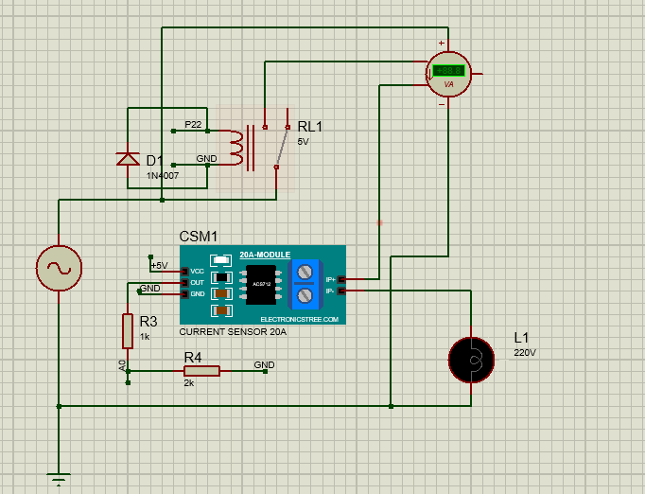
6Figure 5.4: Simulated High-Voltage Relay Circuit for EV Power Delivery
The Node-RED backend simultaneously begins a timer to log the duration (t) of the active state. Using the power formula (P=220V * 32A=7.04kW), the system calculates total energy consumed (E=P * t) upon relay deactivation.

5.5 USER INTERFACE AND BILLING INTEGRATION
The application layer consists of an administrator dashboard and a simulated user-facing interface, both generated via Node-RED Dashboard nodes.
- Administrator View: Displays live occupancy status of the 4 parking bays, current grid power draw, and user logs.
- User View: Simulates the mobile application where drivers view their consumed kW/h, parking duration, and total calculated fee.

To validate the financial capability of the system for the Ethiopian context, the final billing output generates a digital payment prompt intended for integration with local mobile money platforms like Telebirr.
The integrated system was tested against the structured data flow established in the system design. The testing focused on response latency, logic accuracy, and communication stability.
2Table 5.2: Test cases of the system
Test Case ID | Scenario Description | Expected Outcome | Observed Outcome | Status
TC-01 | Authorized Arrival: Input a registered ID string into the Entry Virtual Terminal. | Node-RED verifies ID in the database. LCD displays "Access Granted". Entry Servo rotates 90° to open. | Database returned success in <0.5s. Gate opened and auto-closed after delay. | PASS
TC-02 | Unauthorized Arrival: Input an unregistered ID string into the Entry Virtual Terminal. | Node-RED denies access. LCD displays "Access Denied". Entry Servo remains at 0° (closed). | Database rejected ID. Gate remained secured. Alert logged in admin dashboard. | PASS
TC-03 | Charge Initiation: Card is scanned and system verifies charging rights. | Arduino triggers charging relay. Circuit closes, allowing the simulated 220V/32A power to flow. | Relay switched to normally open (NO) contact successfully. Load registered. | PASS
TC-04 | Power Measurement: Simulate an active charging session for a predetermined duration (e.g., 2 hours). | Node-RED tracks time (t) and calculates energy (E=7.04kW×t). Total energy for 2 hours = 14.08kWh  . | Timer synced perfectly with relay state. Energy consumed was calculated exactly as 14.08 kWh. | PASS
TC-05 | Session Termination: Vehicle leaves the bay, ultrasonic sensor state changes to 'empty'. | Relay deactivates immediately. Charging timer stops. Final energy consumption is locked for billing. | Relay safely disconnected power. Data successfully pushed to the billing module. | PASS
TC-06 | Exit and Billing: User ID scanned at exit. Mobile payment (Demo payment) is confirmed. | Node-RED calculates total fee (Parking + Energy). Upon payment "Success" signal, Exit Servo opens. | Accurate bill generated on user UI. Exit gate actuated only after payment confirmation. | PASS

RESULTS
The virtual simulation confirmed that serial communication between Proteus and Node-RED operated with minimal latency. Gate actuation and relay switching triggered accurately based on database verification. The power calculation logic successfully scaled according to the simulated timer, proving the reliability of the automated billing mechanism. The successful integration of these components validates the proposed architecture as a viable blueprint for physical deployment

CHAPTER SIX

CONCLUSION AND RECOMMENDATION

6.1 CONCLUSION
The rapid adoption of electric vehicles (EVs) globally, and specifically within Ethiopia following the Ministry of Transport’s initiative to transition to electric mobility, has necessitated an urgent upgrade to urban infrastructure. This project successfully addressed the critical gap in existing parking and charging management by designing, simulating, and validating an integrated IoT-Based Automated Electric Vehicle Charging and Smart Parking Management System.
Through the collaborative efforts of the Computer Science, Software Engineering, and Electrical Power and Control Engineering (EPCE) departments at Adama Science and Technology University (ASTU), this study engineered a cohesive system that eliminates the information disconnect between parking availability and charger status.
Because the study emphasized software-hardware integration and logical validation, the entire physical layer was successfully virtualized using Proteus 8 Professional. The Arduino Mega 2560 served as a robust local controller, effectively managing simulated ultrasonic sensors for occupancy, servo motors for automated gate actuation, and virtual terminals for credential scanning. A major technical achievement of this project was the seamless bidirectional communication established between this isolated hardware simulation and external cloud services. Utilizing the COMPIM module and Node-RED middleware, the system achieved low-latency data transfer, enabling real-time database queries, remote hardware control, and a unified administrator dashboard.
Furthermore, the EPCE logic was flawlessly executed. The simulation accurately modeled the power distribution of a standard 220V grid supplying a 32A load, tracking an instantaneous power draw of 7.04 kW. By accurately logging the duration of charging sessions, the system proved capable of automating fair, usage-based billing while simultaneously calculating standard parking durations.
Ultimately, the successful execution of these test scenarios validates the proposed three-layer IoT architecture. The system successfully mitigates driver "range anxiety," reduces unnecessary traffic congestion caused by parking searches, and prevents EV charger hoarding. This virtual proof-of-concept serves as a highly scalable, robust blueprint ready for physical prototyping and eventual deployment in Ethiopian smart city initiatives.

6.2 RECOMMENDATION
While the simulation successfully validated the core logic and architecture of the integrated smart parking and charging system, further development is required to transition this virtual model into a commercially viable, real-world solution. Based on the findings and limitations of this study, the following recommendations are proposed:
1. Transition to Physical Prototyping
The immediate next step is to translate the Proteus simulation into a physical hardware prototype. Future engineering teams should implement physical ultrasonic/geomagnetic sensors, real automated boom barriers, and physical high-voltage contactors. Crucially, the simulated virtual terminals should be replaced with physical RFID card readers and real-time AI-driven Automated License Plate Recognition (ALPR) cameras running algorithms like YOLOv8 on edge devices (e.g., Raspberry Pi).
2. Direct API Integration with Local Mobile Money
To fully realize the automated digital billing aspect for the Ethiopian context, the Node-RED backend should be directly integrated with Ethio Telecom’s Telebirr API or Commercial Bank of Ethiopia (CBE) payment gateways. This will allow the system to autonomously send payment prompts to the driver's smartphone upon exit and enforce idle fees securely without manual intervention.
3. Cloud Migration and Predictive Analytics
As the system scales from a single parking lot to city-wide implementation in Addis Ababa or Adama, the local Node-RED server should be migrated to a robust cloud infrastructure (such as AWS or Azure). Future software engineering iterations should incorporate machine learning algorithms to analyze the historical data collected in the database. This would enable predictive analytics, allowing the mobile application to forecast parking availability and charging demand based on time of day, day of the week, or local traffic conditions.
4. Advanced Power Management and Vehicle-to-Grid (V2G) Integration
To accommodate the strain that mass EV charging will place on the local power grid, future research by the EPCE department should focus on intelligent load balancing. The system should be upgraded to dynamically distribute available facility power among multiple charging vehicles based on their current battery state of charge (SoC). Additionally, future iterations should explore Vehicle-to-Grid (V2G) capabilities, allowing parked EVs to discharge energy back into the grid during peak hours to stabilize local power infrastructure.
5. Policy and Commercial Deployment
It is recommended that local municipal authorities and urban planners adopt this integrated IoT architecture as a standard for new commercial buildings and public parking garages. By providing centralized, real-time data to traffic authorities, this system can provide vital telemetry to support the Ethiopian government’s policies on sustainable urban mobility and environmental conservation.

REFERENCES
- Abdulsaheb, J. A., Nafea, R. M., Al-Jawher, W. A. M., & Hayyawi, M. L. (2024). IoT based smart parking system. Journal Port Science Research, 7(3), 196–203. https://doi.org/10.36371/port.2024.3.1
- Arduino. (n.d.). Arduino Mega 2560 Rev3. https://docs.arduino.cc/hardware/mega-2560
- Luque-Vega, L. F., Michel-Torres, D. A., Lopez-Neri, E., Carlos-Mancilla, M. A., & González-Jiménez, L. E. (2020). IoT smart parking system based on the visual-aided smart vehicle presence sensor: SPIN-V. Sensors, 20(5), 1476. https://doi.org/10.3390/s20051476
- OpenJS Foundation. (n.d.). Node-RED: Low-code programming for event-driven applications. https://nodered.org/
- Soni, A., Atre, A., Raikwar, H., Gupta, P., Sahu, S., & Sahay, S. (2024). IoT based smart car parking system. International Journal of Transportation Engineering and Traffic System, 10(1), 21–28.
- Lin, J., & Zhang, F. (2024). Online reservation and allocation management for integrated parking and charging lots. ITEA Annual Conference, Leeds, UK.
- Future Batteries Journal. (2025). IoT in smart EV charging management: Real-world implementations and future directions. Future Batteries, 12(3), 45-62.
- Devkar, A., Nalawade, M., Patil, S., & Nichal, A. (2025). Review paper on wireless EV charging integrated with IoT based smart parking monitoring system. IJRSI, 12(11), 519-524.
- University of Algarve. (2025). Intelligent monitoring systems for EV charging stations in parking facilities. MDPI Applied Sciences, 15(2), 1-25.
- ScienceDirect. (2025). Digitalization of parking services through smart parking systems. Transportation Research Part C, 162, 104-128.
- Girma, M., & Mulatu, Z. (2025). Evaluating corridor development initiatives in Addis Ababa. Urban, Planning and Transport Research, 13(1), 1-20.
- Ibrahim, N. (2023). Use of digitalization and IoT to alleviate traffic congestion in Addis Ababa. RIT Master's Project.
- Ministry of Transport, Ethiopia. (2025). Ethiopia's plan to roll out 500,000 electric vehicles.
- Node.js Foundation. (2025). Node.js documentation for IoT applications.

APPENDICES

APPENDIX A: ARDUINO MICROCONTROLLER SOURCE CODE
#include <Wire.h>
#include <LiquidCrystal_I2C.h>
#include <Servo.h>
// 1. LCD Setup
LiquidCrystal_I2C lcdEntry(0x20, 16, 2);
LiquidCrystal_I2C lcdExit(0x21, 16, 2);
Servo gateEntry, gateExit;
// 2. Pin Mapping
const int trig1=2, echo1=3, trig2=4, echo2=5, srv1=6;
const int trig3=7, echo3=8, trig4=9, echo4=10, srv2=11;
const int btnPark = 12, btnEV = 13;
const int relayPin = 22; // THE PROVEN PIN
// 3. Logic Flags
int usedSlots = 0;
bool isEVAuthorized = false; // Security Interlock
#define THRESHOLD 20
void setup() {
Serial.begin(9600);
// RELAY FIRST: Force it to be an output and turn it OFF immediately
pinMode(relayPin, OUTPUT);
digitalWrite(relayPin, LOW);
lcdEntry.init(); lcdEntry.backlight();
lcdExit.init(); lcdExit.backlight();
gateEntry.attach(srv1); gateEntry.write(0);
gateExit.attach(srv2); gateExit.write(0);
pinMode(btnPark, INPUT); pinMode(btnEV, INPUT);
lcdEntry.print("ENTRY READY");
lcdExit.print("EXIT READY");
Serial.println("--- ASTU SYSTEM: BOOT SUCCESS ---");
}
void loop() {
// --- PART 1: ENTRY GATE ---
int d1 = getDist(trig1, echo1);
if (d1 > 0 && d1 < THRESHOLD && usedSlots < 10) {
lcdEntry.setCursor(0,1); lcdEntry.print("TAP CARD... ");
if (Serial.available() > 0) {
String id = Serial.readStringUntil('\n');
lcdEntry.clear(); lcdEntry.print("1:Park 2:EV+P");
// Wait for button press (this is the only blocking part)
while(digitalRead(btnPark) == LOW && digitalRead(btnEV) == LOW);
if (digitalRead(btnEV) == HIGH) {
isEVAuthorized = true;
lcdEntry.clear(); lcdEntry.print("MODE: EV USER");
} else {
isEVAuthorized = false;
lcdEntry.clear(); lcdEntry.print("MODE: STANDARD");
}
delay(1000);
lcdEntry.setCursor(0,1); lcdEntry.print("ACCESS GRANTED");
gateEntry.write(90);
while(getDist(trig2, echo2) > THRESHOLD); // Wait for car to clear
usedSlots++;
delay(1000); gateEntry.write(0);
lcdEntry.clear(); lcdEntry.print("ENTRY READY");
while(Serial.available()) Serial.read(); // Flush buffer
}
}
// --- PART 2: EXIT & CHARGING (RELAY 22) ---
int d3 = getDist(trig3, echo3);
if (d3 > 0 && d3 < THRESHOLD) {
if (isEVAuthorized) {
// Logic verified: Close Relay
digitalWrite(relayPin, HIGH);
lcdExit.clear(); lcdExit.print("CHARGING EV...");
lcdExit.setCursor(0,1); lcdExit.print("TAP TO PAY");
Serial.println("ACTION: Relay 22 CLOSED. Power ON.");
// Loop until card is returned (type in terminal)
while(Serial.available() == 0) {
delay(100);
}
digitalWrite(relayPin, LOW); // Open Relay
Serial.println("ACTION: Relay 22 OPENED. Power OFF.");
}
else {
lcdExit.clear(); lcdExit.print("STANDARD EXIT");
lcdExit.setCursor(0,1); lcdExit.print("TAP TO EXIT");
while(Serial.available() == 0);
}
// FINISH EXIT
while(Serial.available()) Serial.read();
lcdExit.clear(); lcdExit.print("PAYMENT SUCCESS");
gateExit.write(90);
while(getDist(trig4, echo4) > THRESHOLD);
usedSlots--;
delay(1000); gateExit.write(0);
isEVAuthorized = false; // Reset for next car
lcdExit.clear(); lcdExit.print("EXIT READY");
}
}
// Optimized distance function to reduce lag
int getDist(int t, int e) {
pinMode(t, OUTPUT); digitalWrite(t, LOW); delayMicroseconds(2);
digitalWrite(t, HIGH); delayMicroseconds(10); digitalWrite(t, LOW);
pinMode(e, INPUT);
long dur = pulseIn(e, HIGH, 20000); // 20ms timeout prevents CPU hang
int d = dur / 58;
return (d == 0) ? 999 : d;
}

